**ASSIGNMENT 1**

**CIRCUIT:**

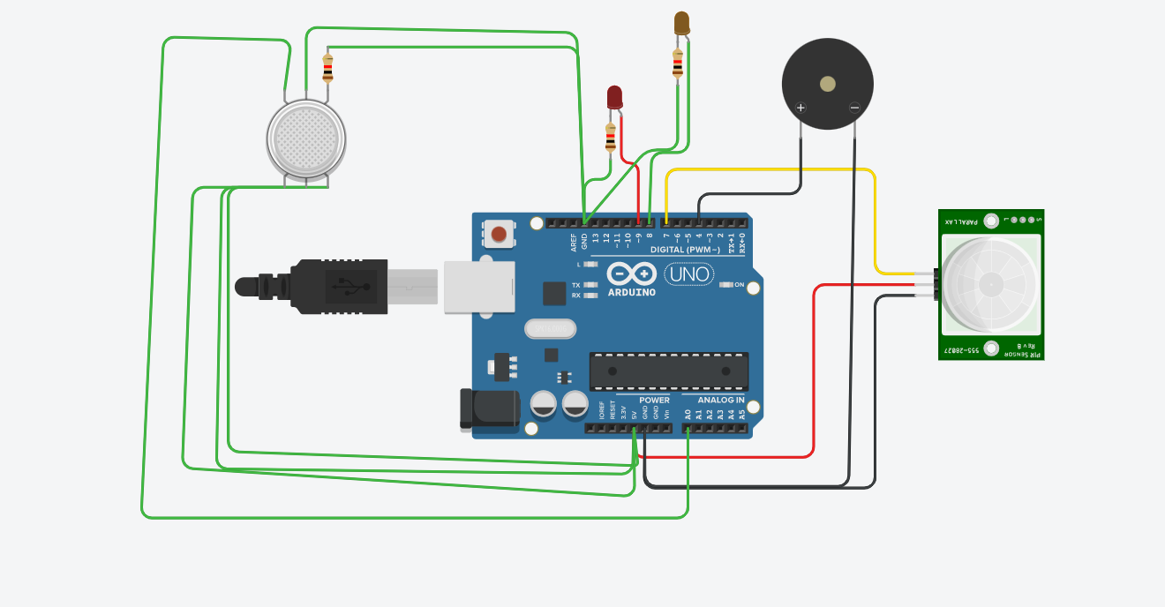

**OUTPUT:**

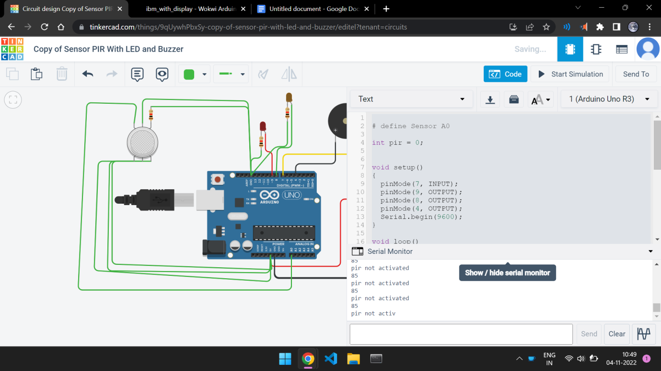

**CODE:**

# define Sensor A0

int pir = 0;

void setup()

{

pinMode(7, INPUT);

pinMode(9, OUTPUT);

pinMode(8, OUTPUT);

pinMode(4, OUTPUT);

Serial.begin(9600);

}

void loop()

{

pir = digitalRead(7);

int sensorg = analogRead(A0);

Serial.println(sensorg);

if ( sensorg >=100 )

{

digitalWrite(8, HIGH);

digitalWrite(4,HIGH);

}

if (pir == HIGH) {

digitalWrite(9, HIGH);

digitalWrite(4, HIGH);

Serial.println("pir acitvated");

} else {

digitalWrite(9, LOW);

digitalWrite(4, LOW);

Serial.println("pir not activated");

}

delay(10);}